DESIGNING PROFESSIONAL BUSINESS CARD

# INTRODUCTION

A small card bearing information (such as name and address) about a business of business representative.

# OVERVIEW OF THE PROJECT

In this project , first we create the empathy map about the topic professional business . next we design the brainstorming map ny collecting the ideas from the group members.by brainstorming ideas,we design the professional.

# PURPOSE OF THE BUSSINESS CARD

A thoughtfully-designed business card does more than carry your contact information, it will make you look professional, built trust in customer , and set your small business apart from others.

# 2.PROBLEM DEFINITION AND DESIGN THINKING

2.1 EMPATHY MAP ;

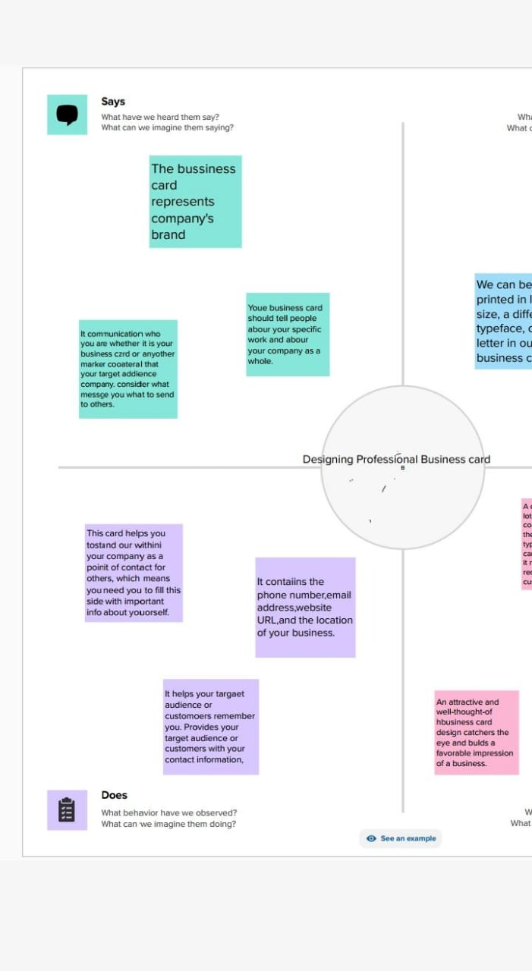

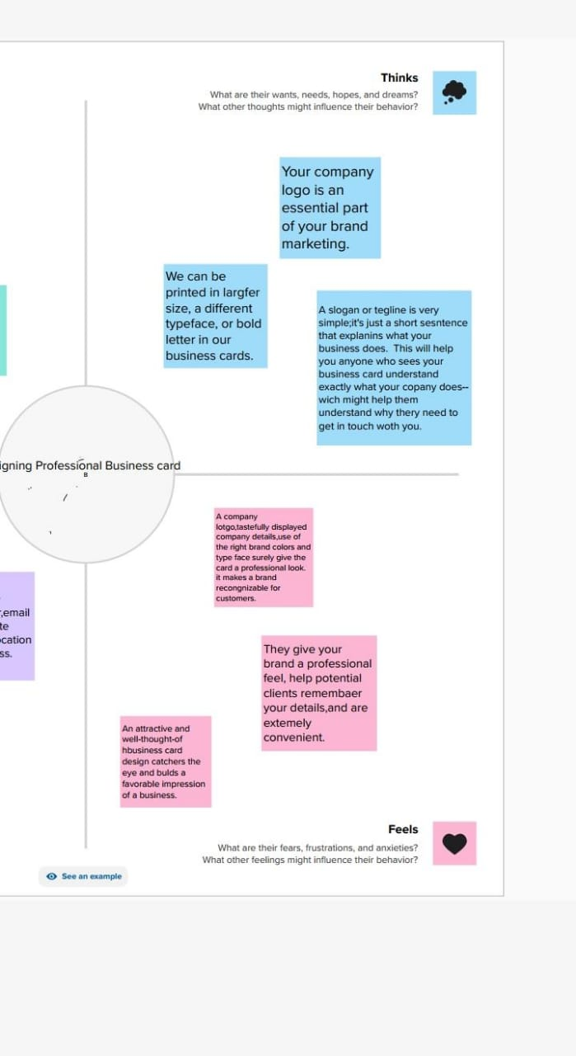

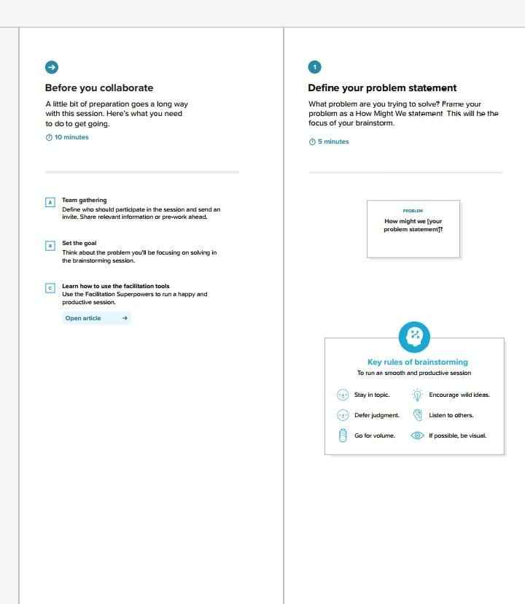

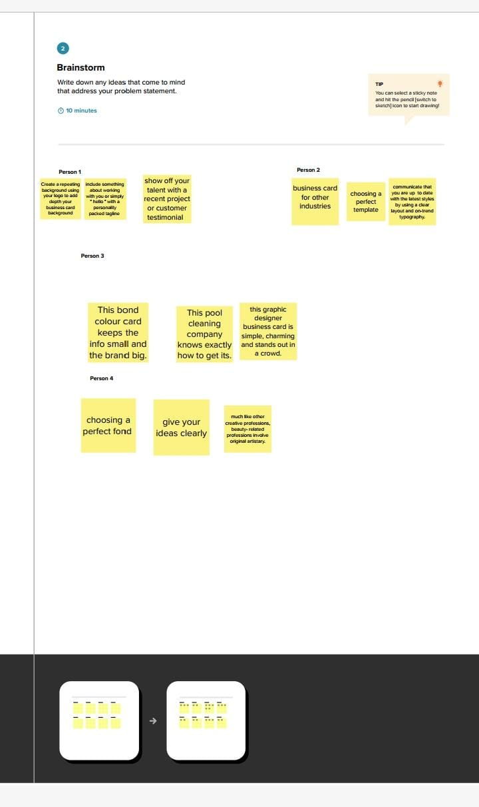

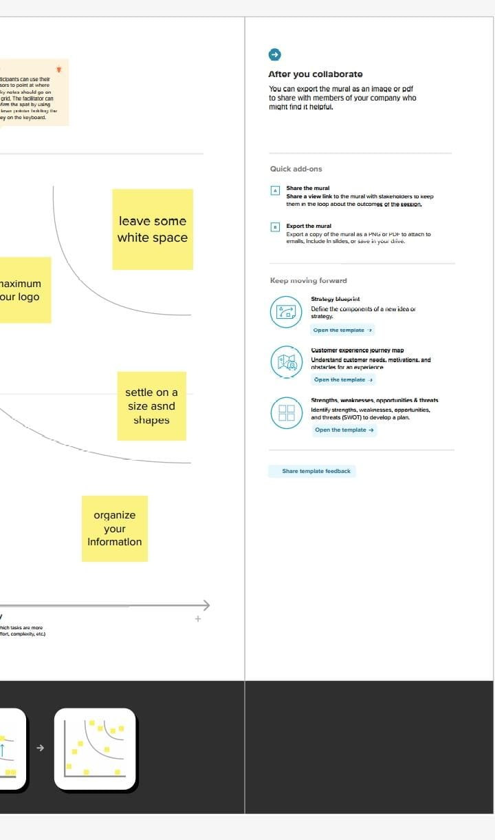

RESULT



# 4 ADVANTAGES AND DISADVANTAGES

ADVANTAGES;

#Designing our own card is the best way to to convey the unique personality of our brand.

The benefit of using the business cards is their affordability.when compared to other advertising optional such as billboards or a digital marketing campaign , business cards are an externely cheep choice.

One thing that is often overload about company cards is the professionalism that they convey . personal cards have been around for a long time and are highly respected amongst business people – handling out a business card lets people know that your’s serious.

A business card lets people know exactly what your company is all about.

DISADVANTAGES

Easily sharing contact information to shaping potential customers perspectives about your venture, when you’ll meet a potential customer or partner , so its smart to have business cards on hand when you share

Your business card design is creative design features an incredible pattern and clean typeface.

# CONCLUSION

Our business card design is creative design feature an clean typeface.

# FUTURE SCOPE

With the appearance of digital marketing the shape and style of the business cards are constanly changing, for example, are integrating QR codes to example , are integrating QR codes to connect business cards with thecnology and make this promotional tool more interative.